SKX-1000E+

SPO2 Simulator

Operation manual

Version: V2.6_2023
Xuzhou Mingsheng electronic Technology Co., LTD
Catalogue
Chapter 1 SKX-1000E+ instrument features and functions ...........................3
Chapter 2 Precautions for SKX-1000E+ instrument use ................................7
Chapter 3 SKX-1000E+ instrument connection description ..........................9
Chapter 4 SKX-1000E+ software introduction ............................................12
Chapter 5 SKX-1000E+ Button description ……………....................................14
Chapter 6 SKX-1000E+ Parameter Performance Descriptio ….....................16
Chapter 7 SKX-1000E+ waveform detailed introduction and detection content .…………........................…………........................…………......................21
Chapter 6 SKX-1000E+ Parameter Performance Descriptio ….....................31

Appendix 1
Weak perfusion characteristics of blood oxygen ........................................32
About the detection method of simulated blood oxygen …........................34

Chapter 1 SKX-1000E+ instrument features and functions
SKX-1000D+ SPO2 Simulator is a signal simulation tool specially developed by Xuzhou Mingsheng Company for the development and detection of blood oxygen saturation products. Because it can produce analog optical signals with different curves and different pulse amplitude-it is the necessary and preferred tool for the development of blood oxygen products. It has a wide signal amplitude range. It can simulate a variety of intensity and frequency of blood oxygen signals, which is an important tool for the development of blood oxygen products.The simulator also has the function of detecting blood oxygen measurement products, and is used to test whether the parameters of blood oxygen products can meet the requirements of national standards. The following chapters will describe the Settings during the detection process in detail.

Features are as follows:
1, On the basis of SKX-1000D+, electrocardiogram (ECG) and respiratory (Resp) functions are added.
2, With 10 multipurpose connectors of ECG products, it is convenient to connect and test the performance of various ECG products.
3, built-in 18650 large capacity lithium battery, power management module, in the use of the process to ensure stable power supply, low interference output. A standard micro usb universal interface power charger is available.
4, using menu operation, parameter change is simple, convenient, fast, easy to set.
5, using OLED display, display menu content.
6, simple button operation, menu management, easy to use.
7, built-in waveform setting instructions in both Chinese and English, easy to understand the waveform setting and parameter selection.
8, The simulator is a transmission blood oxygen optical simulator.

Blood oxygen part performance introduction:
- External analog finger, can be easily connected to any blood oxygen test instrument;
- It is a transmission type multi-functional optical analog instrument, built-in commonly used BCI, NELLCOR, Mindray, Masimo, BioLight, EDAN, Creative, OmiMax waveform curve;
- Blood oxygen saturation simulation range:
80%, 85%, 90%, 98%, 4-point numerical detection and calibration, error ≤1%;
60%, 65%, 70%, 75%, 4-point numerical detection and calibration, error ≤2%;
- Pulse rate simulation range:
30bpm, 60bpm, 80bpm, 100bpm, 120bpm, 160bpm, 180bpm, 240bpm, a total of 8 test points, error ≤1bpm;
- Pulse intensity:
1%, 2%, 4%, 5%, 10%, 20%;
- Sensitivity:
Normal, high two options;
- Dc component:
Auto,1 - 100;
- Exchange:
There are two options: yes and no.

Note:For blood oxygen products commonly produced by large manufacturers on the market, most of the curves used are NELLCOR curves, and a small amount are BCI. Please select the corresponding Minary curve for Mindray series products. Brand Monitor If the instrument is marked with the MASIMO logo, use the corresponding MASIMO curve. Since the product database does not necessarily cover all instruments at home and abroad, the blood oxygen of some instruments may not be detected or the detection value is different. Welcome to feedback to our company for product improvement and upgrading!
At present, we have tested brands including Mindray, Bolete, Kericon (Shanghai Likang), Tianrong, Libang, Jinkewei (BCI), Komen, Philips and other brands of instruments.

Ecg part performance introduction:
- Normal wave, can output different amplitude and type of 12-channel synchronous waveform I, II, III, aVR, aVL, aVF, V1, V2, V3, V4, V5, V6;
- Sharp Angle waveform, used to detect heart rate accuracy and heart rate range waveform;
- Calibration, a standard amplitude signal used to calibrate the amplitude of ECG equipment;
- Arrhythmia, four arrhythmia waveforms in the MIT database;
- Square wave, using square wave to measure scanning speed and filter bandwidth range test;
- Sine wave, used to detect amplitude and frequency characteristics and other related performance;
- RespWave: detects the performance of respiratory parameters in ECG devices with respiratory function. The respiratory waveform is output through RA-LL standard II leads. The baseline impedance is fixed at 1K, and the impedance change is about 2Ω impedance respiratory waveform, and the value of respiratory rate can be changed;
- Triangular, which can change the bottom width of the triangular waveform;
- ASY Pace, detecting the suppression and recognition of pacing signals by ECG equipment;
- QRS_T Wave is used to simulate the QRST waveform of the human body and detect the related performance of T wave and R wave. It can simulate the QRS waveform of T wave amplitude, heart rate value, R wave amplitude and R wave width. By changing the width of R wave, the ECG waveform of adults, children or newborns can be simulated;
- Pace Wave, which detects the suppression of pacemaker signals by ECG devices, has pulse pacemaker signals whose pulse width can be continuously adjusted, and is used to detect the pulse pacemaker ability of ECG;
- Synthesise, interference of ECG signals superposed by 35Hz, 50Hz, 60Hz sine wave signals.

Chapter 2 Precautions for SKX-1000E+ instrument use
1, Because the blood oxygen saturation detection needs to correspond to optical signals, when using this simulator, please try to avoid detection under strong light, which may cause numerical deviation, especially when digital blood oxygen detection, you can use some shading facilities to block light when necessary;
2, The analog finger of the analog instrument has positive and negative (or up and down) directivity, and can work normally only when the direction is correct;
3, when the simulator is working, if the charger is connected, it may increase the power frequency interference of the ECG waveform, under normal circumstances, the ECG module part of the instrument will filter this part of the interference, the interference of the respiratory waveform may be larger, will produce and superimpose the sine wave signal, the simulated waveform of blood oxygen saturation, will also cause waveform overlap processing frequency interference;
4, After power-up, the simulator automatically generates a blood oxygen saturation value of 98, pulse rate of 80, pulse intensity of 10%, blood oxygen parameter data and code of NELLCOR curve are 6 normal ECG waveform, respiratory rate of 15bpm respiratory waveform;
5, When there is no key operation within one minute, the screen will automatically turn off. After pressing any key, the screen will resume display. After the screen is turned off, the indicator will start to work and blink every 5 seconds. After the screen is restored, the indicator stops blinking;
6, when using NELLCOR or Mindray curve, please choose 660nm/905nm blood oxygen probe, so that it is easy to maintain consistency with clinical data; When using BCI curves, use a 660nm/940nm blood oxygen probe for easy consistency with clinical data. When selecting the MASIMO curve, use the MASIMO original probe

Standby working time of the simulator
1, When the power is displayed as 0%, the analog device can automatically shut down after working for 1 minute under the startup state. If any key is selected, the analog device will delay the shutdown time until there is no key processing within 1 minute.
2, When the power is displayed as 10%, the analog device can automatically shut down after 5 minutes of operation under the startup state. If any key is selected, the time shutdown is delayed until there is no key processing within 5 minutes.
3, When the power is lower than 0%, the simulator cannot be turned on again.

Chapter 3 SKX-1000E+ instrument connection description
Blood oxygen analog finger connector
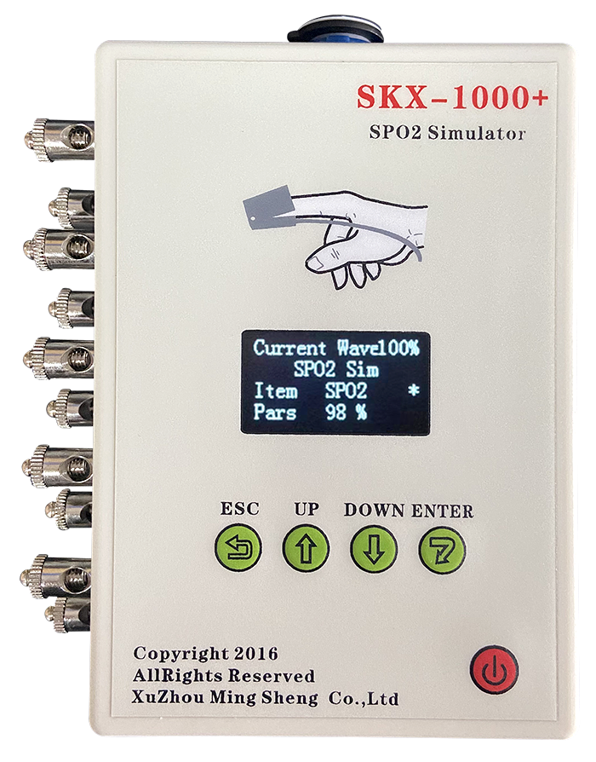
Cardiac conductance buckle or clip joint
OLED display
Charger interface
Power switch
Ecg machine banana plug jack
Operating key

Battery level display

Connection of blood oxygen probe to simulated finger:
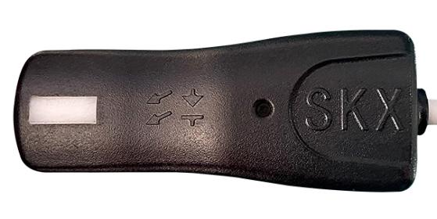
Luminous window
Direction mark
Place this side of the simulated finger (shown above) on the receiving tube end of the blood oxygen probe
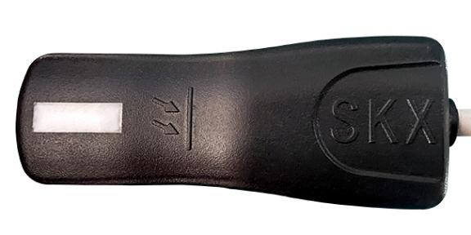
Direction mark
Light receiving window
Place this side of the simulated finger (shown above) on the red tube end of the blood oxygen probe
1, The part marked withon the blood oxygen simulation finger, please point to the light-emitting tube part of the blood oxygen probe; Please point the part marked withon the finger of the blood oxygen simulator at the receiving tube part of the blood oxygen probe. At the same time, be sure to note that the white window position on the finger should be aligned with the receiving tube position, otherwise the effective value may not be obtained.
2, When the blood oxygen probe is empty, the red light of the blood oxygen probe is blinking. When the simulated finger is placed in the blood oxygen probe, if it enters the normal working state, the red light of the blood oxygen probe is steady on.
3, In the process of detecting blood oxygen saturation, if there is a certain deviation in the blood oxygen value, you can check whether the value is corrected by repeatedly placing the analog finger.
Please note that the analog finger will turn red for 1 second within 2-5 seconds of turning it on.
Connection of the electrocardiogram:
1, Electrocardiogram machine connection: RA-R(right hand), LA-L (left hand), LL-F (left leg), RL-RF (N) (right leg), C1-C6 chest guide;
2, monitor connection: RA- right hand (white), LA- left hand (black), LL- left foot (red), RL- right foot (green), C1-C6 chest guide (brown);
3, three lead connection method: RA- right hand (white), LA- left hand (black), LL- left foot (red);
4, European standard connection method: L-LA R-RA RF(N)-RL F-LL C-V;
5. The default lead II amplitude is 1mV when the simulator is turned on. In the heart rate detection waveform, square wave, sine wave and QRS wave, the amplitude of lead II is all 1mV. If the amplitude of ECG equipment is detected, please connect II for amplitude detection; if the amplitude of lead I is detected, please exchange LL and LA leads to detect the signal amplitude of lead I. If you need to test the amplitude of the V lead, connect RA, LA, LL short-circuit together and then connect the LL end of the analog meter, and connect the tested V lead to the RA end of the analog meter, then you can test whether the signal amplitude of V meets the requirements.

Chapter 4 SKX-1000E+ software introduction
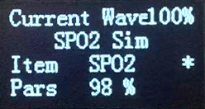
Software interface description:
The simulator uses OLED screen to display content, and the software interface has 4 lines of display content
The first line:Current wave 5%
The current waveform is represented as a label of the type of waveform generated by the current analog instrument, and 100% power indicator percentage;
This behavior is displayed by default and cannot be changed.
The second line:SPO2 Sim
Indicates that the waveform type of the current simulator is SPO2 Sim;
This behavior changes the first layer of the menu, where different waveform types can be selected.
The third line:Item SPO2
Indicates that the waveform item generated by the current simulator is SPO2;
This behavior can change the second layer of the menu, you can select the items contained under this waveform, the specific content of the project will be detailed in the subsequent waveform type introduction.
The fourth line:Pars 98%
Represents the specific parameters of the waveform generated by the current simulator;
This behavior can change the third layer of the menu, you can change the specific parameter value of the waveform, this parameter is the corresponding waveform project content, the following details.

* symbol indicates the current cursor, representing the current operation in a different menu layer; In the third layer menu, the * symbol has special significance, indicating that by increasing the key and decreasing the key can move left and right in the parameter value. When the confirm key is selected, the * will be displayed as? , indicates that the hundreds, tens, and ones of the parameter values can be directly changed; Select the confirm key again,? Will change to a * symbol, indicating that the change is complete.

Chapter 5 SKX-1000E+ Button description
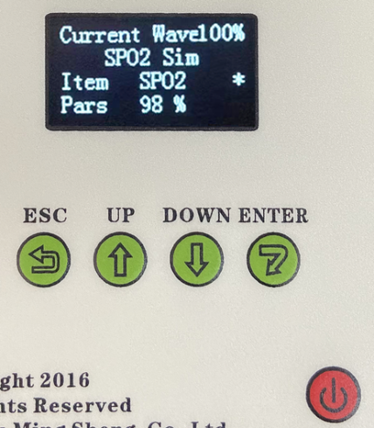
Battery level display

The simulator has five buttons
From left to right are the return key, the increase (right) key, the decrease (left) key, the Confirm key and the on key in the lower right corner.
Key definition:
ESC:
From the lower-level menu to the higher-level menu, the first-level menu is the highest level menu, and the third-level menu is the lowest level menu.
UP:
Select menu items backward in the first and second layer menus, the ECG waveform is the first item, and the menu is set to the last item.
DOWN:
Select menu items in the first and second layer menus. The ECG waveform is the first item and the menu is the last item.
ENTER:
Selecting the Confirm key will enter the next layer menu from the high-level menu, and in the third layer menu, the confirm key will confirm the parameter change and generate the corresponding waveform.
On key:
Power on: Hold down the on key for two seconds. When "Operation Help" is displayed, press the select key again to enter the main interface of the instrument.
Shutdown: Under the state displayed on the screen, long press the on key for two seconds to shut down the instrument.

Note:When Operation Help is displayed after the device is powered on, the function of the increase key is to turn down a page, and the function of the decrease key is to turn up a page. The key does not have any effect at this time, and you can only press the Select key to enter the main screen of the device.
The operation help displayed is optional. Here are the steps to turn off the operation help:
1. Long press On key, then press ESC to enter the main interface of the instrument.
2, Use UP or DOWN, set "SPO2 Sim" to "MenuSetup", and then press ENTER, then the item in the third line becomes Default.
3, use UP3 more times, set "Default" to "ShowHelp", press ENTER, at this time * from the third line to the fourth line.
4. Press ESC, return * to the right of "ShowHelp", use UP, and go to "Settings".
5, press ENTER, * move to the "OK" line, then press ENTER, * change? number
6, Click ENTER. At this time, "OK" changes to "Save completed", indicating that the save is complete.
7, long press the open key, power off, will skip the "operation help", directly into the main interface of the instrument.
Note: The * symbol on which line can change the numeric parameter on which line; In the parameter line, which value is followed by the * symbol, the value can be changed, and the role of ESC in this line is to move the * symbol left and right.

Chapter 6 SKX-1000E+ Parameter Performance Description
There are 13 types of waveform in this simulator, which are
Serial number | Waveform type | intro
1 | SPO2 Sim | Simulates human oxygen saturation
2 | Normal Wave | Two different simulated human ECG waveforms
3 | Sharp Wave | Waveform for detecting heart rate accuracy and heart rate range
4 | Calibration | A standard amplitude signal used to calibrate the amplitude of ECG equipment
5 | Arrhythmia | Four arrhythmia waveforms in the MIT database
6 | Square Wave | It is used to test the curve scanning speed and time constant performance of ECG equipment
7 | Sine Wave | Used to detect amplitude and frequency characteristics and other related performance
8 | RespWaveve | Measurement of respiratory parameter performance in ECG devices with respiratory function
9 | Triangular | Triangular waveform that can change the width of the bottom
10 | ASY Pace | Triangular waveform that can change the width of the bottom
11 | QRS_T Wave | It is used to simulate the QRST waveform of the human body and detect the related performance of T wave and R wave
12 | Pace Wave | Detection of pacemaker signal suppression by ECG equipment
13 | Synthesise | Interference of ECG signals with superimposed 35Hz, 50Hz, 60Hz sine wave signals
Waveform type parameter list description
Waveform type | Item | Pars
SPO2 Sim | SPO2 | SPO2 range: 60%, 65%, 70%, 75%, 80%, 85%, 90%, 98%, 8-point numerical detection calibration
SPO2 Sim | PR | PR range: 30bpm, 60bpm, 80bpm, 100bpm, 120bpm, 160bpm, 180bpm, 240bpm, a total of 8 test points
SPO2 Sim | AM | AM range: 1%, 2%, 4%, 5%, 10%, 20%
SPO2 Sim | Style | BCI, NELLCOR, Mindray, Masimo, BioLight, EDAN, Creative, OmiMax

Waveform type | Item | Pars
Normal Wave | Normal | Heart rate range: 20 bpm-300 bpm
Normal Wave | Sinus | Heart rate range: 20 bpm-100 bpm
Normal Wave | AM | Amplitude range: 0.5mV, 1mV, 2mV, 3 kinds of fixed amplitude

Waveform type |  | Item |  | Pars
Sharp Wave |  | HR |  | Heart rate range: 20 bpm-400 bpm
 |  | AM |  | Amplitude range: 0.10mV-5.00mV
 |  | Direct |  | UP,Down
Waveform type | Item |  | Pars
Calibration | HR |  | Heart rate range: 30 bpm-120 bpm
Calibration | AM |  | Amplitude range: 0.10mV-5.00mV
Calibration | Width |  | Width range: 40 ms-150 ms

Waveform type | Item | Pars
Arrhythmia | aami3a | Heart rate: 80 bpm or 40 bpm
Arrhythmia | aami3b | Heart rate: 60 bpm or 30 bpm
Arrhythmia | aami3c | Heart rate: 120 bpm
Arrhythmia | aami3d | Heart rate: 90 bpm or 45 bpm

Waveform type | Item | Pars
Square Wave | Fre | Frequency range: 0.1Hz-5.0Hz
Square Wave | AM | Amplitude range: 0.10mV-4.00mV

Waveform type | Item | Pars
Sine Wave | Fre | Frequency range: 0 Hz to 150 Hz
Sine Wave | AM | Amplitude range: 0.10mV-5.00mV
Sine Wave | P_AM | Voltage range: 10 mV-500 mV

Waveform type |  | Item | Pars
RespWaveve |  | Resp | Heart rate range: 5 bpm-120 bpm
 |  | Resp_AM | Amplitude range: 0.3R-3.0R
 |  | Circle | Frequency range: 20bpm-120bpm
 |  | RespStop | Time range: 0 S-120 S
Waveform type | Item |  | Pars
Triangular | HR |  | Heart rate range: 30 bpm-200 bpm
Triangular | R Width |  | Width range: 10 ms - 200 ms
Triangular | AM |  | Amplitude range: 0.10mV-5.00mV
Triangular | Direct |  | UP,Down
Waveform type | Item |  | Pars
ASY Pace | Pace HR |  | Heart rate range: 30 bpm-200 bpm
ASY Pace | Width |  | Width range: 0.1ms - 2.0ms
ASY Pace | Pace AM |  | Amplitude range: 0.10mV-4.00mV
ASY Pace | Direct |  | UP,Down

Waveform type | Item | Pars
QRS_T  Wave | T_mV | Amplitude range: 0.00 mv-1.20 mV
QRS_T  Wave | R_mV | Amplitude range: 0.10mV-4.00mV
QRS_T  Wave | R_HR | Heart rate range: 10 bpm-200 bpm
QRS_T  Wave | R_Width | Width range: 10 ms - 120 ms

Waveform type | Item | Pars
Pace Wave | Pace HR | Heart rate range: 20 bpm-300 bpm
Pace Wave | Width | Width range: 0.1ms - 2.0ms
Pace Wave | Pace_AM | Amplitude range: 0.10mV-5.00mV
Pace Wave | Direct | UP,Down
Waveform type | Item | Pars
Synthesise | bpm | Heart rate value: 80 bpm
Synthesise | Hz | Frequency range: 30 Hz - 60 Hz
Synthesise | AM | Amplitude range: 0.05mV-1.00mV

 | Item | Pars
MenuSetup | Default | You can select any waveform type as the power-on Default
MenuSetup | Language | The software language is Chinese and English
MenuSetup | PowerOff | Set the automatic shutdown time (unit: hour) for keyless operation
MenuSetup | ShowHelp | Whether the key help is displayed after the startup
MenuSetup | Settings | Whether to save the Settings after changing the software Settings for the next startup
MenuSetup | Factory | Restore factory default factory Settings
MenuSetup | About | MingSheng
MenuSetup | Mode | Product model set by the manufacturer
MenuSetup | ID Num | Special customized special interface
MenuSetup | BrigheNS | Set the display brightness, a total of 8 levels 1-8

Chapter 7 SKX-1000E+ waveform detailed introduction and detection content
1, SPO2 Sim：
Blood oxygen values were 98%, 90%, 85%, 80%, 75%, 70%, 65%, 60%; Default value: 98%;
PR value range:30bpm, 60bpm, 80bpm, 100bpm, 120bpm, 160bpm, 180bpm, 240bpm;Default value: 80bpm;
AM range:1%, 2%, 4%, 5%, 10%, 20%;Default value: 10%;
Style:BCI, NELLCOR, Mindray, Masimo, BioLight, EDAN, Creative, OmiMax;
Parst:Normal, Height two options;
Dcset:Auto, 1-100;
Change:Yes,NO two options;

2, Ecg waveform:
Scope of application: Test simple signal function, whether each lead waveform is consistent with the analog waveform.
Note: Under this waveform, a respiratory waveform of 20bpm is generated synchronously. Please change the respiratory wave amplitude in the respiratory wave.
Note: The following waveforms only correspond to normal sinus ECG waveforms, and other waveforms correspond to II lead waveforms.

I lead waveform gain *1
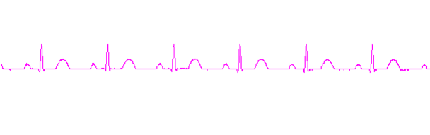
II lead waveform gain *1
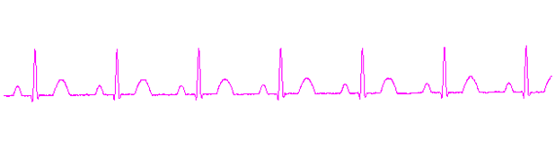
III lead waveform gain *1
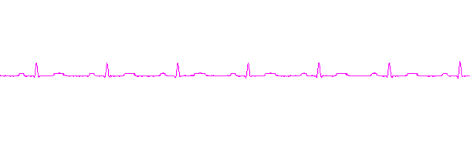
V1 lead waveform gain *1
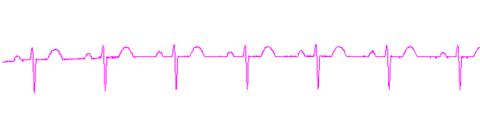
V2 lead waveform gain *1
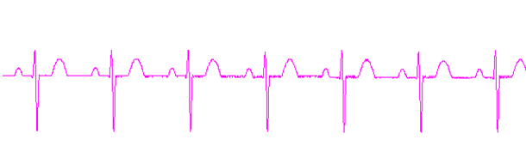
V3 lead waveform gain *1
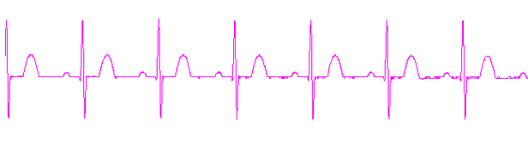

V4 lead waveform gain *1
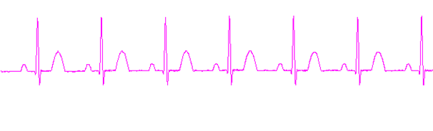
V5 lead waveform gain *1
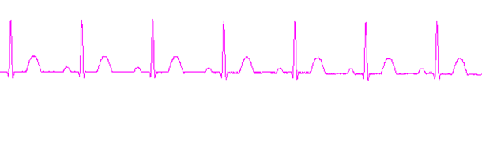
V6 lead waveform gain *1
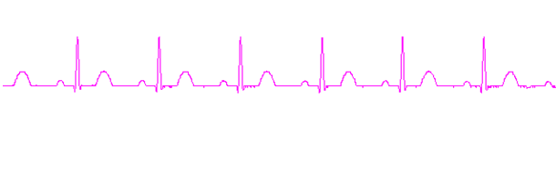
3, Sharp Wave:
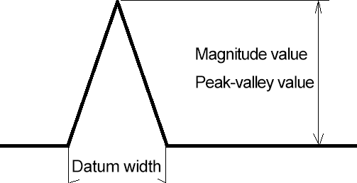
Heart rate range: 20bpm -400 bpm The default is 75 bpm
Base width: 80ms
Direction: Up and down by default
Range: 0.10-5.00mV Step size 0.01mV The default value is 1.00mV
Scope of application: 1. Test whether the detection range of heart rate meets the national standard
2. Detect heart rate accuracy for signals of different amplitudes
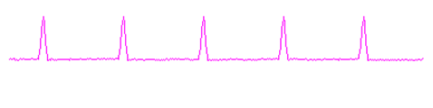
4, Calibration:
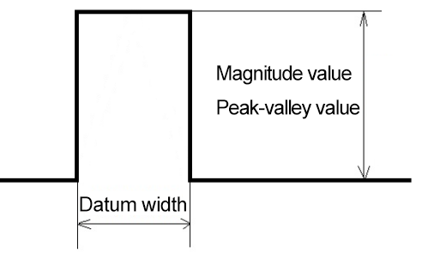
Heart rate range: 30 bpm - 120 bpm 60 bpm by default
Amplitude range: 0.10-5.00mV The default value is 1.00mV
Base width: 40ms-150ms, default 100ms
Scope of application:
1. Amplitude calibration of ECG equipment
2, low frequency corresponding
5, Arrhyythmia:
Waveform type: double connection rate (heart rate of 80 or 40)
Slow double connection rate (heart rate of 60 or 30)
Fast double connection rate (heart rate is 120)
Bidirectional contraction (heart rate of 90 or 45)
Scope of application: heart rate meter accuracy and response to irregular heart rate
Double rate (heart rate of 80 or 40)
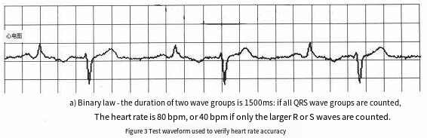
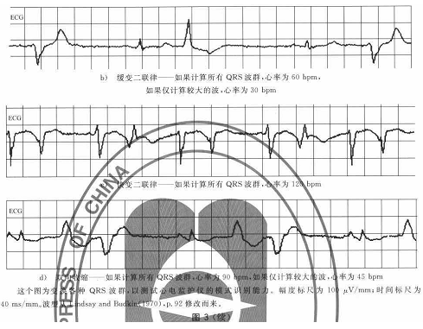

6, Square Wave:
Frequency range: 0.1-5.0Hz Step 0.1Hz The default value is 1.0Hz
Range: 0.10-4.00mV Step size 0.01mV The default value is 1.00mV
Scope of application: 1, scanning speed test
2. Time constant test
II lead waveform gain *1
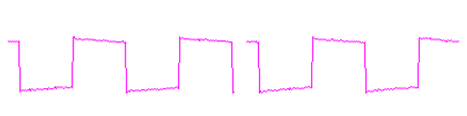
7, Sine Wave:
Frequency range: 0 to 150Hz Step Length 1Hz The default value is 10Hz
Range: 0.10-5.00mV Step size 0.01mV The default value is 1.00mV
Bias voltage: 10-500mV Step length 1mV Default 10mV
Scope of application: 1, test amplitude and frequency characteristics
2. Test the bias voltage
II lead waveform gain *1, the waveform is the same when the bias voltage is ±400mV as when the unbiased voltage
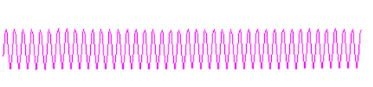 10Hz
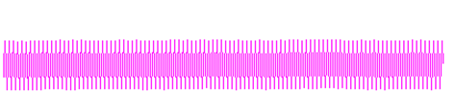 25Hz
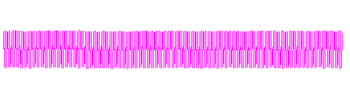 40Hz
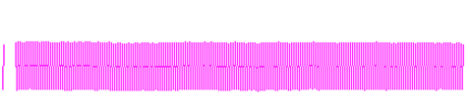
50Hz
 100Hz

8, RespWaveve:
Heart rate range: 60 bpm
Breath value: 5-120 bpm The default is 15bpm
Breathing amplitude: 0.3R-3.0R Default 2.5R Changes the size of the respiratory impedance
Waveform period: Frequency range: 20bpm-120bpm The default is 30bpm
Choking time: Time range: 0 S-120 S The default value is 0 S
Baseline impedance: 1K
Scope of application: Test breathing rate, breathing gain
Baseline impedance: respiratory waveform at 1K
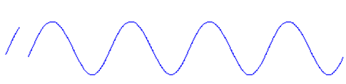
9, Triangular:
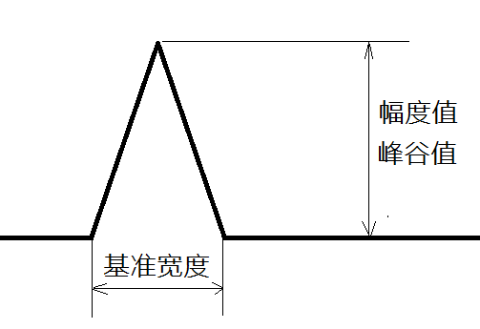
Heart rate range: 30bpm -200 bpm The default is 75 bpm
R width: 10ms - 200ms
R amplitude: 0.10-5.00mV, default 1.00mV
Direction: Up, down, up by defaultScope of application: 1. Test whether the detection range of heart rate meets the national standard;
2, detect the heart rate accuracy of signals with different reference widths;
3. Test the voltage swing rate of the pacing signal;
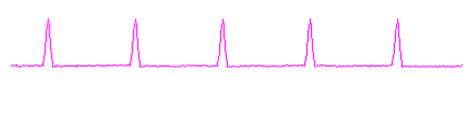

10, ASY Pace:
Heart rate range: 30-200 bpm, default 75bpm
P width: 0.1ms-2.0 ms, default 2.0 ms
P amplitude: 0.10mV-4.00mV, default 1.00mV
P direction: up, down, default up
Signal characteristics: the width of the rising and falling edge of the pacing pulse signal is less than 3uS
Scope of application: 1, pacing signal detection
2. Pacing signal test of different amplitude
Pulse signal: 4mV, 0.1ms, single pulse

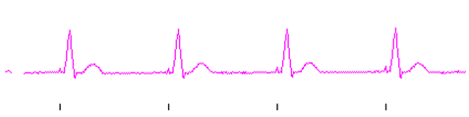
Pacemaker signal号
11, QRS_T Wave:
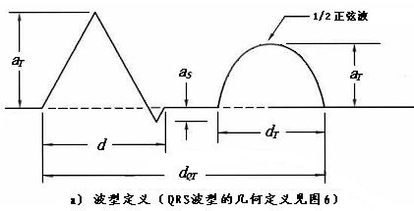
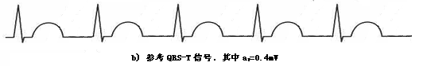
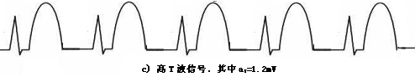

Waveform description: d= bottom width; =T wave amplitude;
=280ms；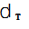=360ms；
=R wave amplitude
T amplitude: 0.00mV-1.20mV The default is 0.20mV
R amplitude: 0.10-4.00mV The default is 1.00 mV
R Heart rate: 10-200 bpm 75 bpm by default
R Width: 10ms-120ms The default is 80ms
Scope of application:
1, QRS wave detection
2, Inhibition ability of high T wave
3, heart rate meter amplitude range detection
4, width range detection (adult, child, newborn)
5, amplitude detection range (adult, child, newborn)

12, Pace Wave:
P Heart rate: 20-300 bpm, default 60 bpm
P width: 0.1ms-2.0ms, default 2.0ms
P amplitude: 0.10mV-5.00mV, default 1.00mV
P direction: Up, down, default up
Signal characteristics: the width of rising edge and falling edge is less than 3uS
Scope of application: 1, pacing signal detection
2, Pacing signal test with precise signal amplitude

13, Superimposed waveform:
Heart rate range: 80 bpm
Frequency range: 30Hz-60Hz
Range: 0.05mV-1.00mV, default: 0.10mV
Interference signal selection: 35Hz (myoelectric interference), 50Hz (power frequency) interference, 60Hz interference
Scope of application: Different amplitude of different interference signal removal detection

Chapter 8 SKX-1000E+ after-sales service
The company will provide you with an 18-month warranty from the date of purchase of the instrument (battery, charger warranty for one year), the warranty expires, responsible for lifelong maintenance, and charge maintenance materials as required.

* Our company will not provide free warranty service for the following reasons:
▪ Failure caused by disassembly and modification of the product without authorization.
▪ Analog finger damaged by external damage, no warranty is provided.
▪ Failure caused by careless falls and drops in the process of use and handling.
▪ The failure caused by careless falls and falls in the process of use and handling.
▪ Failure caused by not following the correct instructions in the operating manual.
▪ Failure caused by self-repair without our company's permission.
▪Failure caused by the irresistible forces of nature caused by natural disasters, fires, earthquakes, etc.

* If you need warranty service, please contact our technical service center directly in the form of telephone, letter, fax, etc., such as contact with other personnel or departments, there may be information transmission interruption, resulting in misunderstanding of time and service, the most important thing is to affect your normal use.

* After-sales service information:
▪ Full name: Xuzhou Mingsheng Electronic Technology Co., LTD
▪ Address: 726, Block A, Shimao Diamond International, Yunlong District, Xuzhou City
▪ ZIP Code: 221004
▪ Tel: 0516-83460606, 83469046
▪ Chuanzhen: 0516-83469046
▪ E-mail: xzFRD@163.com
▪ Company website: WWW.XZMSDZ.COM
Appendix 1
Weak perfusion characteristics of blood oxygen
Because the performance of digital oximetry mainly depends on the precision of digital probe, the performance of its receiving tube directly determines the weak perfusion performance of digital oximetry. Relative to the traditional analog signal method to get blood oxygen saturation, in a certain degree of weak perfusion, such as more than 1%, the performance of the digital probe is stronger than the analog probe, can improve anti-interference, mainly in no matter anyone's fingers thick or thin, children or newborns can get a good performance. When simulating blood oxygen in extreme fields such as newborn or children's fingers, if the fingers are very thin, the light transmittance of the fingers is too strong, which may cause misjudgment of the probe falling off detection. If the misjudgment is not caused, because the light transmission is too strong, it will lead to the front-end amplification part of the pulse detection circuit can not be simulated amplification, (because amplification will cause loss of pulse amplifier saturation state), so the waveform amplification function will be lost. In addition, because of the high light transmission intensity, although through adjusting the luminescence intensity of the luminescence tube, the received light intensity is still very strong. Therefore, in this state, the performance of analog blood oxygen is inferior to that of digital blood oxygen.
- The digital oxygen receiving circuit has no limit on the light transmission intensity of the finger, so it improves the anti-interference ability in use and is suitable for a variety of people. However, the digital receiving tube has the potential to cause AC signal saturation after too strong DC signal. When the DC component is too large, it will cause the AC signal to work in an irregular interval, so it is suggested that the digital reception should come with luminous brightness adjustment, for the digital receiving tube work in a most reasonable space.

2.because the weak perfusion performance of digital blood oxygen completely depends on the performance of the receiving tube, so for a certain digital receiving tube, its weak perfusion performance is also determined, restricting the weak perfusion can not be further improved, after testing its weak perfusion performance can only be around 1%, can not be further improved.

3. Because the analog probe uses multistage signal amplification, for example, the pulse signal can be amplified and reduced through the adjustment of luminous intensity first, the pulse signal can be amplified by amplifying the pulse carrier signal, and finally the pulse signal can be amplified by high-precision AD and other ways to collect the pulse signal. Through the above three ways, the weak perfusion performance of blood oxygen can be improved, far more than the weak perfusion performance of digital probe. However, the above method has special circumstances, such as newborns or children, because the finger is small and thin, will lead to the finger light intensity is very strong, may lead to the first two kinds of signal amplification part performance failure, if you can overcome the above problems, the weak perfusion performance of the analog probe is much stronger than the digital probe.

About the detection method of simulated blood oxygen
The diode drive part can adjust the current through the diode to change the luminous intensity through the analog quantity "SPO2_DRV"
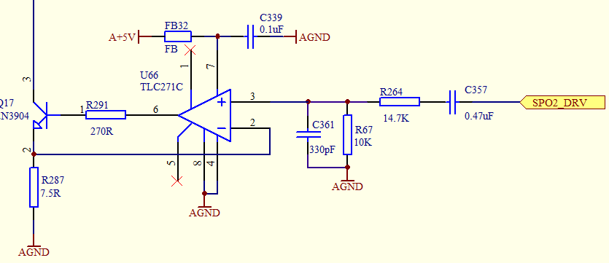
Receiving tube part circuit
The waveform received by the differential amplification receiving tube is similar to the above luminous waveform, except that the blood oxygen waveform signal is already contained.
As the above waveform is similar, the blood oxygen waveform data has been contained, in this case, the waveform should be amplified according to the amplitude of the waveform, and finally enter the AD part of the CPU for direct acquisition, it is noted that there is no need to separate the above waveform, only need to be in the CPU program end according to the timing of the luminous part. It is OK to collect the waveform at the corresponding time point, and it is recommended that AD signals should be collected before closing and switching the light tube, so as to obtain effective data to the maximum extent.
The sequential circuit of the blood oxygen device driving the luminescent tube is shown below, with four modes:
1, red light, infrared light alternating, the pulse period is the same, the dark period and the luminous period are equal.
The luminescence period can be set to 200us-1ms. The Dash series Nellcor module uses a 500us luminescence cycle

Red light
Infrared light
Red light

Infrared light


Dark period
2, The timing of red and infrared light is fixed, as shown in the figure below:
The luminous order of red light and infrared light can be exchanged, but the cycle is the same cycle, the setting range is 200us-1ms, the dark period between red light and infrared light can be 200-1ms, and the fixed period between each group of luminous light can be customized according to demand, the default can be set to 8ms.

Red light

Infrared light

Infrared light

Red light


Dark period

3, red and infrared light continuous light, no dark interval in the middle or dark interval is very small, less than 100us, as shown in the following figure:
In this case, the time interval of each group of luminous cycles is fixed, which can be defined as 8ms or other values

Red light

Infrared light

Red light

Infrared light


Dark period

4, red and infrared light continuous light, no dark interval in the middle or dark interval is very small, less than 100us, as shown in the following figure:
In this case, the red and infrared light emission periods can be defined as 200us-1ms, and the time interval of each group of emission cycles is fixed, which can be defined as 8ms or other values

Red light
Infrared light

Red light
Infrared light

Dark period

Please note:SKX-1000E+ SPO2 Simulator can detect the first three of the four cases. If the blood oxygen device is the fourth case of luminescence drive, please adjust the luminescence timing to meet the three cases.

Receiving tube part circuit
The waveform received by the differential amplification receiving tube is similar to the above luminous waveform, except that the blood oxygen waveform signal is already contained. The sampling point should be located in the middle to the last point of the light emitting tube switching time series, when the data is relatively stable.
Sampling point
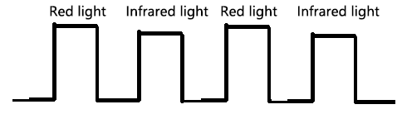
Sampling point

As the above waveform is similar, the blood oxygen waveform data has been contained, in this case, the waveform should be amplified according to the amplitude of the waveform, and finally enter the AD part of the CPU for direct acquisition, it is noted that there is no need to separate the above waveform, only need to be in the CPU program end according to the timing of the luminous part. It is OK to collect the waveform at the corresponding time point, and it is recommended that AD signals should be collected before closing and switching the light tube, so as to obtain effective data to the maximum extent.

